RobotMonitor.rtf Testing

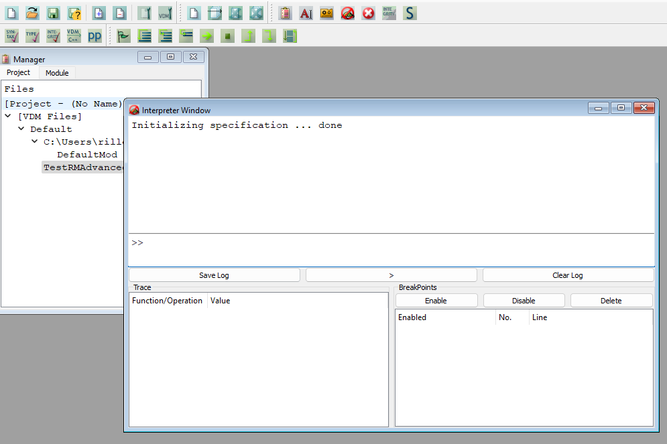

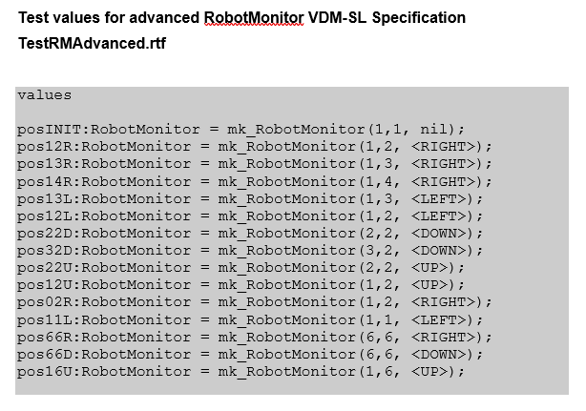

**1. Testing the invariant**

|  |  |
| --- | --- |
| **Test #** | 1A |
| **Purpose of testing** | To test if the invariant is correct. |
| **Input data** | (1,1,nil) |
| **Expected result** | TRUE – Col, row and move within range |
| **Result** |  |
| **PASS/FAIL** | PASS |

|  |  |
| --- | --- |
| **Test #** | 1B |
| **Purpose of testing** | To test if the invariant is correct |
| **Input data** | (7,7,nil) |
| **Expected result** | BROKEN INVARIANT – temp out of range |
| **Result** |  |
| **PASS/FAIL** | PASS |

2. Testing the Move Right Operation

|  |  |
| --- | --- |
| **Test #** | 2A |
| **Purpose of testing** | To test precondition |
| **Input data** | (1,2, <RIGHT>) |
| **Expected result** | TRUE – position (1,2) moves right |
| **Result** |  |
| **PASS/FAIL** | PASS |

|  |  |
| --- | --- |
| **Test #** | 2B |
| **Purpose of testing** | To test precondition |
| **Input data** | (6,6,<RIGHT>) |
| **Expected result** | FALSE - Not possible to move right at this position |
| **Result** |  |
| **PASS/FAIL** | PASS |

|  |  |
| --- | --- |
| **Test #** | 2C |
| **Purpose of testing** | To test postcondition |
| **Input data** | (1,2,<RIGHT>), (1,3,<RIGHT>) |
| **Expected result** | TRUE – The position should move from (1,2) to (1,3) increasing the column by 1 |
| **Result** |  |
| **PASS/FAIL** | PASS |

|  |  |
| --- | --- |
| **Test #** | 2D |
| **Purpose of testing** | To test postcondition |
| **Input data** | (1,2,<RIGHT>), (1,4,<RIGHT>) |
| **Expected result** | FALSE – The column will increase by 2 instead of 1 |
| **Result** |  |
| **PASS/FAIL** | PASS |

3. Testing the Move Left Operation

|  |  |
| --- | --- |
| **Test #** | 3A |
| **Purpose of testing** | To test precondition |
| **Input data** | (1,3,<LEFT>) |
| **Expected result** | TRUE – position 1,3 will move left |
| **Result** |  |
| **PASS/FAIL** | PASS |

|  |  |
| --- | --- |
| **Test #** | 3B |
| **Purpose of testing** | To test precondition |
| **Input data** | (1,1,<LEFT>) |
| **Expected result** | FALSE – position 1,1 cannot move left to 0 |
| **Result** |  |
| **PASS/FAIL** | PASS |

|  |  |
| --- | --- |
| **Test #** | 3C |
| **Purpose of testing** | To test postcondition |
| **Input data** | (1,3,<LEFT>), (1,2,<LEFT>) |
| **Expected result** | TRUE – position 1,3 moves left by 1 column to position 1,2 |
| **Result** |  |
| **PASS/FAIL** | PASS |

|  |  |
| --- | --- |
| **Test #** | 3D |
| **Purpose of testing** | To test postcondition |
| **Input data** | (1,2,<LEFT>), (1,3,<LEFT>) |
| **Expected result** | FALSE – operation cannot move left on post |
| **Result** |  |
| **PASS/FAIL** | PASS |

4. Testing the Move Up Operation

|  |  |
| --- | --- |
| **Test #** | 4A |
| **Purpose of testing** | To test precondition |
| **Input data** | (2,2,<UP>) |
| **Expected result** | TRUE – Position of the row moves up 1 |
| **Result** |  |
| **PASS/FAIL** | PASS |

|  |  |
| --- | --- |
| **Test #** | 4B |
| **Purpose of testing** | To test precondition |
| **Input data** | (1,6,<UP>) |
| **Expected result** | FALSE – operation cannot move up to 0 as the condition is greater or equal to 0 |
| **Result** |  |
| **PASS/FAIL** | PASS |

|  |  |
| --- | --- |
| **Test #** | 4C |
| **Purpose of testing** | To test postcondition |
| **Input data** | (2,2,<UP>), (1,2,<UP>) |
| **Expected result** | TRUE – the position will go -1 on row from 2,2 to 1,2 |
| **Result** |  |
| **PASS/FAIL** | PASS |

|  |  |
| --- | --- |
| **Test #** | 4D |
| **Purpose of testing** | To test postcondition |
| **Input data** | (1,2,<UP>), (2,2,<UP>) |
| **Expected result** | FALSE – Operation cannot move down as the row is going + 1 from 1,2 to 2,2 |
| **Result** |  |
| **PASS/FAIL** | PASS |

5. Testing the Move Down Operation

|  |  |
| --- | --- |
| **Test #** | 5A |
| **Purpose of testing** | To test precondition |
| **Input data** | (2,2,<DOWN>) |
| **Expected result** | TRUE – Position will move down + 1 |
| **Result** |  |
| **PASS/FAIL** | PASS |

|  |  |
| --- | --- |
| **Test #** | 5B |
| **Purpose of testing** | To test precondition |
| **Input data** | (6,6,<DOWN>) |
| **Expected result** | FALSE –Operation cannot move down beyond 6 as it will give false as its over the condition of MAX 6 |
| **Result** |  |
| **PASS/FAIL** | PASS |

|  |  |
| --- | --- |
| **Test #** | 5C |
| **Purpose of testing** | To test postcondition |
| **Input data** | (2,2,Down), (3,2,Down) |
| **Expected result** | TRUE – The position will move row + 1 down from 2,2 to 3,2 |
| **Result** |  |
| **PASS/FAIL** | PASS |

|  |  |
| --- | --- |
| **Test #** | 5D |
| **Purpose of testing** | To test postcondition |
| **Input data** | (3,2,<DOWN>), (2,2,<DOWN>) |
| **Expected result** | FALSE – Operation cannot move up as the row is going - 1 from position 3,2 to 2,2 |
| **Result** |  |
| **PASS/FAIL** | PASS |

6. Testing Get Row Operation

|  |  |
| --- | --- |
| **Test #** | 6A |
| **Purpose of testing** | To test postcondition |
| **Input data** | (1, (1,2,<RIGHT>), (1,2,<RIGHT>)) |
| **Expected result** | TRUE – Gives output of 1 from the old value and final value. |
| **Result** |  |
| **PASS/FAIL** | PASS |

|  |  |
| --- | --- |
| **Test #** | 6B |
| **Purpose of testing** | To test postcondition |
| **Input data** | (2, (1,2,<RIGHT>), (1,2,<RIGHT>)) |
| **Expected result** | FALSE – Gives output of 1 from the old value and final value instead of 2. |
| **Result** |  |
| **PASS/FAIL** | PASS |

7. Testing the Get Column Operation

|  |  |
| --- | --- |
| **Test #** | 7A |
| **Purpose of testing** | To test postcondition |
| **Input data** | (2, (2,2,<UP>), (2,2,<UP>)) |
| **Expected result** | TRUE – Gives output of 2 from the old value and final value. |
| **Result** |  |
| **PASS/FAIL** | PASS |

|  |  |
| --- | --- |
| **Test #** | 7B |
| **Purpose of testing** | To test postcondition |
| **Input data** | (3, (2,2,<UP>), (2,2,<UP>)) |
| **Expected result** | FALSE – Gives 2 from the old value and final value instead of output value of 3. |
| **Result** |  |
| **PASS/FAIL** | PASS |

8. Testing the Get Move Operation

|  |  |
| --- | --- |
| **Test #** | 8A |
| **Purpose of testing** | To test postcondition |
| **Input data** | (<DOWN>,(2,2,<DOWN>),(2,2,<DOWN>) |
| **Expected result** | TRUE – the output of the move is <DOWN> |
| **Result** |  |
| **PASS/FAIL** | PASS |

|  |  |
| --- | --- |
| **Test #** | 8B |
| **Purpose of testing** | To test postcondition |
| **Input data** | (<UP>,(2,2,<DOWN>),(2,2,<DOWN>) |
| **Expected result** | FALSE – the output of the move is <UP> however the remainder returns false |
| **Result** |  |
| **PASS/FAIL** | PASS |

9. Testing the Exit Operation

|  |  |
| --- | --- |
| **Test #** | 9A |
| **Purpose of testing** | To test precondition |
| **Input data** | (6,6,<DOWN>) |
| **Expected result** | TRUE – Exit require position for column and row should be 6,6 with the input resulting a true |
| **Result** |  |
| **PASS/FAIL** | PASS |

|  |  |
| --- | --- |
| **Test #** | 9B |
| **Purpose of testing** | To test precondition |
| **Input data** | (1,2,<RIGHT>) |
| **Expected result** | FALSE – Exit require position for column and row should be 6,6 which the input is 1,2 resulting in false. |
| **Result** |  |
| **PASS/FAIL** | PASS |

|  |  |
| --- | --- |
| **Test #** | 9C |
| **Purpose of testing** | To test postcondition |
| **Input data** | (6,6,<RIGHT>), (1,1,nil) |
| **Expected result** | TRUE – The read for the condition of the position after exiting should result in it to become 1,1 and nil on the move. |
| **Result** |  |
| **PASS/FAIL** | PASS |

|  |  |
| --- | --- |
| **Test #** | 9D |
| **Purpose of testing** | To test postcondition |
| **Input data** | (1,2,<RIGHT>), (1,3,<RIGHT>) |
| **Expected result** | FALSE – The read value 1,2 is not set to be at at the exit point of 6,6 which is the condition and instead 1,3 resulting in a false. |
| **Result** |  |
| **PASS/FAIL** | PASS |